SQL Database Querying – Employee & Machine Information

Scenario:
I was tasked with retrieving specific information about employees, their machines, and their departments to support organizational IT operations. This included identifying machines requiring updates, locating employees in certain departments, and resolving machine issues in a specific building.

Tasks & Solutions
Task 1: List all organization machines
- Action: Determine the total number of rows returned from the machines table after selecting the device_id and operating_system columns.
SELECT device_id, operating_system
FROM machines;
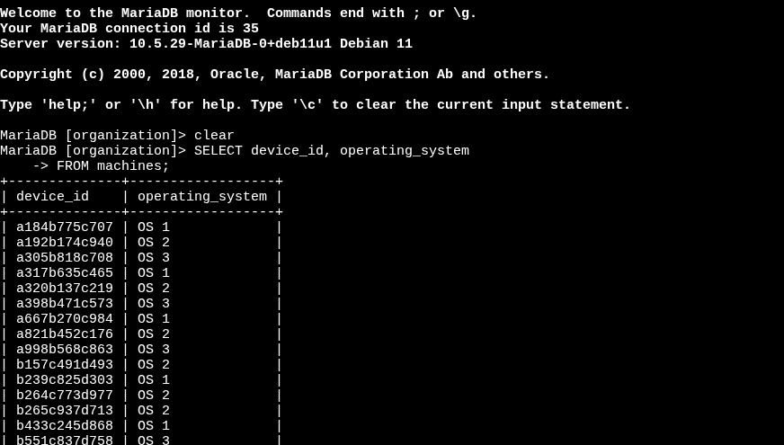

- Result: 200 rows returned

Task 2: Retrieve a list of the machines with OS 2
- Action: Identify how many machines in the database are using the OS 2 operating system.
SELECT device_id, operating_system
FROM machines
WHERE operating_system = 'OS 2';
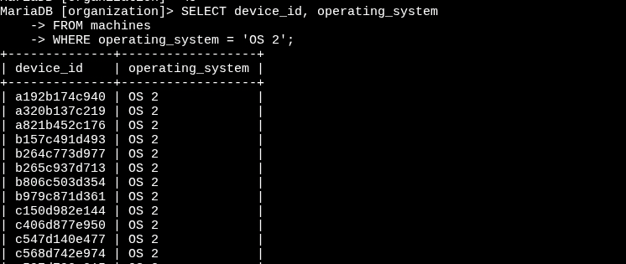
- Result: 80 machines with OS 2

Task 3: List employees in specific departments
- Action A: Retrieve the employee_id of the first row returned when filtering employees from the Finance department.
SELECT *
FROM employees
WHERE department = 'Finance';
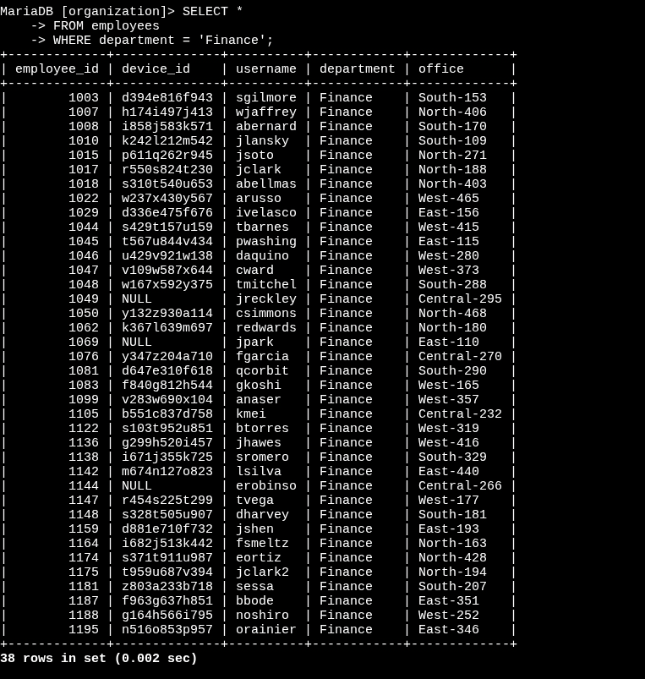
- Result: First employee ID = 1001

- Action B: Determine the total number of employees working in the Sales department.
SELECT *
FROM employees
WHERE department = 'Sales';
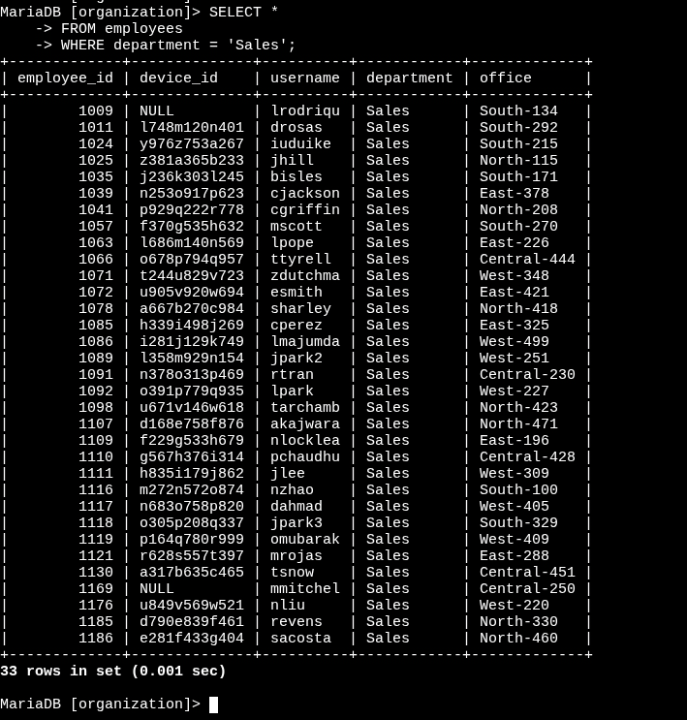
- Result: 33 employees in Sales

Task 4: Identify employee machines
- Action A: Identify which employee is assigned to the office South-109.
SELECT *
FROM employees
WHERE office = 'South-109';
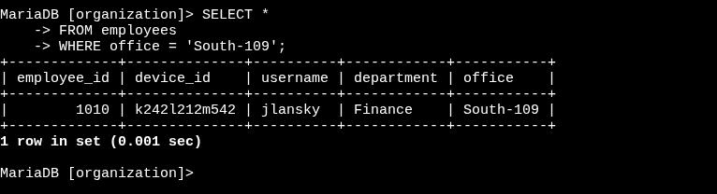Result: Employee = jlansky
Action B: Determine which department the first employee listed in the South building belongs to.
SELECT *
FROM employees
WHERE office LIKE 'South%';
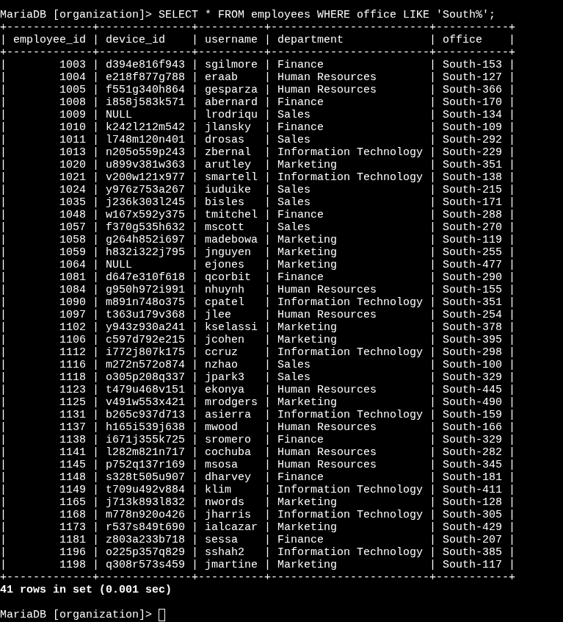
- Result: First employee’s department = Information Technology

Key SQL Skills Demonstrated
- Using SELECT to retrieve specific columns.
- Applying WHERE to filter results.
- Using LIKE with % for pattern-based filtering.
- Interpreting query results to solve operational tasks.
Outcome
This project demonstrated my ability to query and filter data from relational databases to support IT operations such as system updates, compliance notices, and issue resolution. By leveraging SQL filtering and pattern-matching techniques, I was able to provide accurate and actionable data insights to the team.

